Visitation of the Staff of our Foundress St. Teresa of Jesus
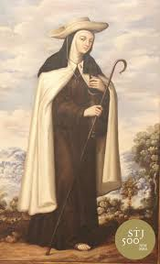
Dec.2 Tuesday at 6:00 p.m.
Solemn Mass at Cristo Rey
Carmelite Monastery in San Francisco with the Archbishop Most Reverend Salvatore Cardileone presiding

Dec.3 Wednesday at 8:00 a.m.
Solemn Mass at Mount St. Joseph
Carmelite Monastery in San Jose presided by Fr. Matthew Williams, O.C.D. & Fr. Patrick Sugrue, O.C.D. as homilist
- 11:00 a.m. Santa Clara Carmel
Liturgical Celebration with a conference by Fr. James Geoghegan, O.C.D.

- 5:00 p.m. Carmel by the Sea
Carmelite Monastery, Liturgical Celebration with a Power-point presentation by Fr. Robert Elias Barcelos, O.C.D.

All are most welcome to celebrate this epic occasion to receive the iconic relic of Teresa of Avila’s Staff which accompanied the saint on her many foundations of Carmelite monasteries and which will be visiting selected Carmelite communities world-wide during this jubilee celebration of the V Centenary of her birth!

